28.75: a) 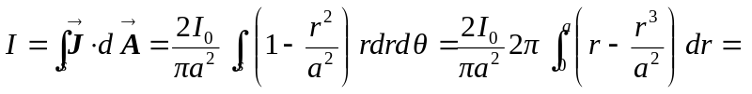
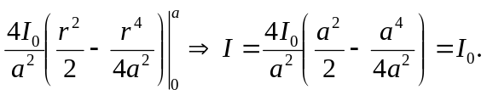
b) For 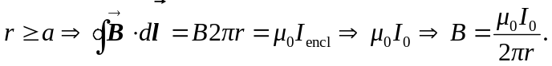
c) For 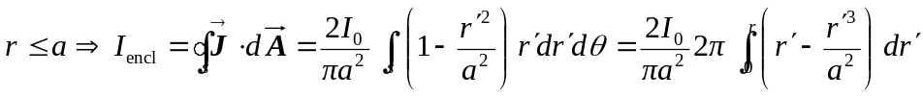
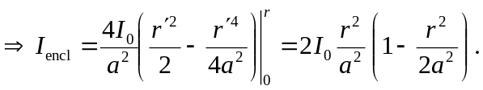
d) For 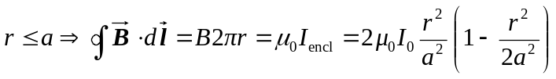
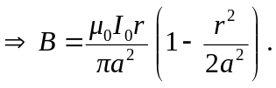
At 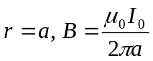 for both parts (b) and (d).

